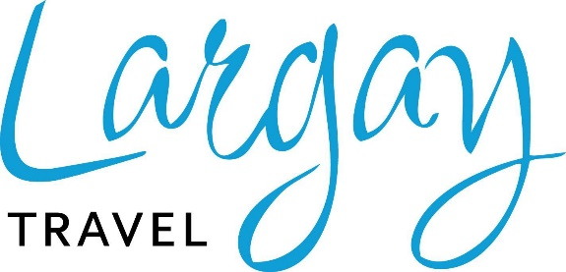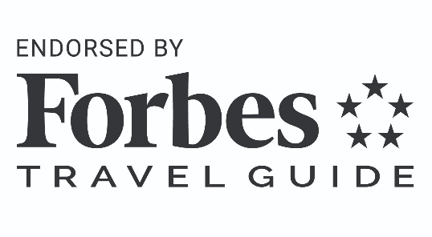

MEDIA CONTACT:
Scott Largay - Director of Marketing scott@largaytravel.com / 203-757-9481

Largay Travel Named Forbes Travel Guide-Endorsed Agency

Largay Travel, Waterbury, CT (August 1st, 2023) – Luxury travel agency Largay Travel has been named among the first Forbes Travel Guide-endorsed travel agencies in the world.
Forbes Travel Guide ("FTG") recognized Largay Travel for its leadership in the industry, dedication to elevating the role of travel advisors, support of hotels that have earned FTG Star Ratings and engagement with FTG as a trusted source for objective, third-party verification of exceptional hospitality experiences.

“The recognition from FTG is one of the highest professional achievements and personal highlights in my 43-year career in travel,” said Paul Largay, CEO and Chief Culture Creator at Largay Travel. “It is a proud and humbling moment to be recognized by FTG, whose shared commitment to service excellence and consistency mirrors Largay’s core organizational values and service standards.”

FTG is the only independent global rating system for luxury hotels, restaurants, spas and ocean cruises. Its 65th annual list for 2023 honors nearly 1,400 rated hotels in 81 countries. The coveted Five-Star, Four-Star and Recommended awards are earned through incognito inspections on FTG’s hundreds of exacting quality and service standards. Evaluators assess up to 900 standards, and service level comprises 70 percent of the score.

“It is such an honor and privilege to have Largay Travel recognized and endorsed by Forbes Travel Guide,” said Scott Largay, Director of Marketing of Largay Travel. “Growing up around and working in the travel industry, I have always known the importance that Forbes Travel Guide plays in the level of service and standards travel suppliers strive to obtain. To be one of the first travel agencies in the world to be endorsed and join this esteemed group is one of the top personal and professional highlights of my career.”

As a member of Virtuoso®, the leading global network specializing in luxury and experiential travel, Largay Travel offers its clients exclusive access, rare experiences and unparalleled value, resulting in bespoke itineraries created by the world’s best providers of upscale travel. As a network, Virtuoso’s combined annual sales of $28–$32 billion allow the group to negotiate enhanced traveler advantages. For clients of Largay Travel, this means complimentary upgrades and additional perks that enrich their overall stay.

“FTG acknowledges Largay Travel’s commitment to world-class service, which complements FTG’s own principles,” said Richard Lebowitz, Senior Vice President of Travel Industry Outreach for Forbes Travel Guide. “Through its endorsed relationship with FTG, Largay Travel’s completed a range of dedicated training, communications and engagement across its advisor
network that distinguishes FTG Star Ratings as a trusted source of hotels vetted for service and facility excellence. We are grateful and honored to collaborate with the Largay Travel team.”

To learn more about Largay Travel, click here, and to learn more about Forbes Travel Guide, click here.

About Largay Travel
Largay Travel was founded in 1969 by Roland F. Largay. Paul Largay, Roland’s nephew, joined the organization in 1982. Amanda Klimak, current company president, equity partner, and Virtuoso advisory board member, joined the team in 2001. Collectively, they’ve traveled the world and built one of New England’s premier travel management organizations.
Headquartered in Waterbury, Connecticut, Largay partners with a group of over 120 dedicated, experienced travel advisors, whose average tenure exceeds 20 years. To ensure all the unique needs of each respective sector and traveler are satisfied, the company is strategically divided into three separate divisions: leisure travel, group & incentive, and corporate services.
Largay Travel is a branch of the Tzell Travel group, and proud members of the exclusive Virtuoso network of trusted travel specialists. Our memberships provide for exclusive travel experiences, and guarantee values not available or accessible to non participants. Virtuoso membership, limited to less than 1% of all global agencies, enables us to offer clients complimentary upgrades, outstanding amenities and privileged access to events throughout the world.
Largay Travel’s value proposition is to provide clarity to the confusion of choices and destination information by discovering what matters to you as a traveler, and subsequently leveraging our knowledge and industry relationships to deliver personalized recommendations and solutions.
Let the principals and staff of Largay Travel share with you their wealth of knowledge, quest for adventure, and countless personal travel experiences, and your travel dreams will quickly become a reality and lifelong memory.

About Forbes Travel Guide
Forbes Travel Guide is the only global rating system for luxury hotels, restaurants, spas and ocean cruises. FTG’s anonymous professional inspectors evaluate based on up to 900 objective standards, with an emphasis on exceptional service, to help discerning travelers select the world's best luxury experiences. The only way to get a Five-Star, Four-Star or Recommended rating is by earning it through their independent inspection process. For more information about Forbes Travel Guide, please visit ForbesTravelGuide.com.

###

